Lebanese American University

Department of Computer Science & Mathematics

CSC 458 – Game Programming



Technical Design Document

Data: 22/04/2021

Project: Magical Forest - Fantasy

**Flowchart:**

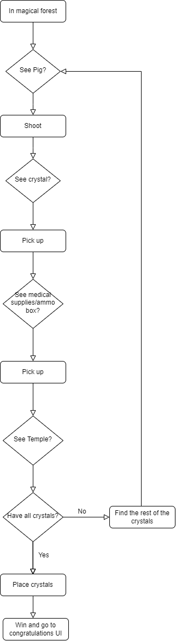

**UML Class Diagrams:**

1) Player.cs: This script controls everything related to the player such as their health, crystals collected, audio of shooting and picking up supply boxes.

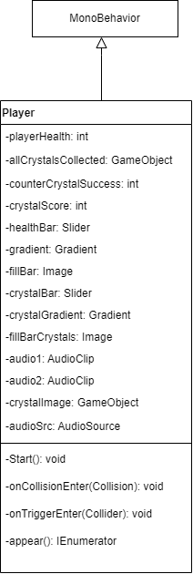

2) Shooting.cs: This script controls everything related to shooting such as shooting enemies, decreasing ammo and instantiating crystals.

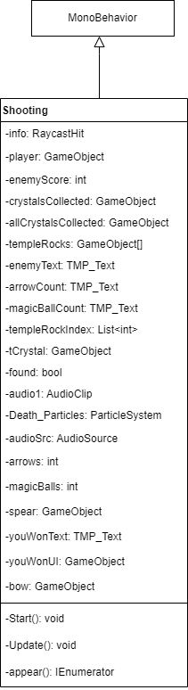

3) Enemy.cs: This script controls everything related to enemies such as moving with animations and displaying the warning sign.

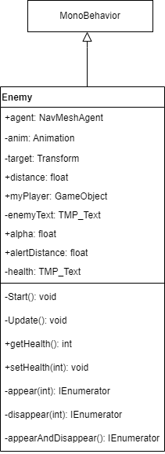

4) Weapons.cs: This script controls the action of changing weapons.

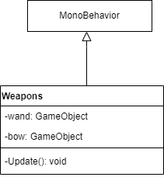

5) Story.cs: This script controls the flow of the story at the beginning.

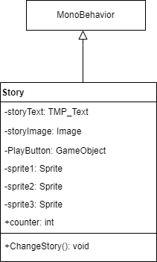

6) LoadNewLevel.cs: This script controls the loading screen.

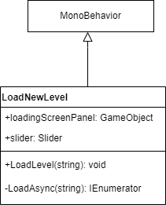

7) MenuScript.cs: This script controls the menu.

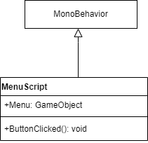

8) PlayAgain.cs: This script controls loading the main scene.

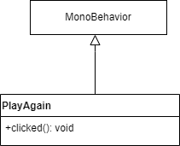

9) BackButton.cs: This script removes the menu.

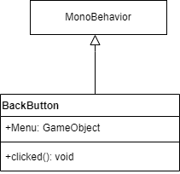

10) QuitGame.cs: This script allows the player to quit the game.

